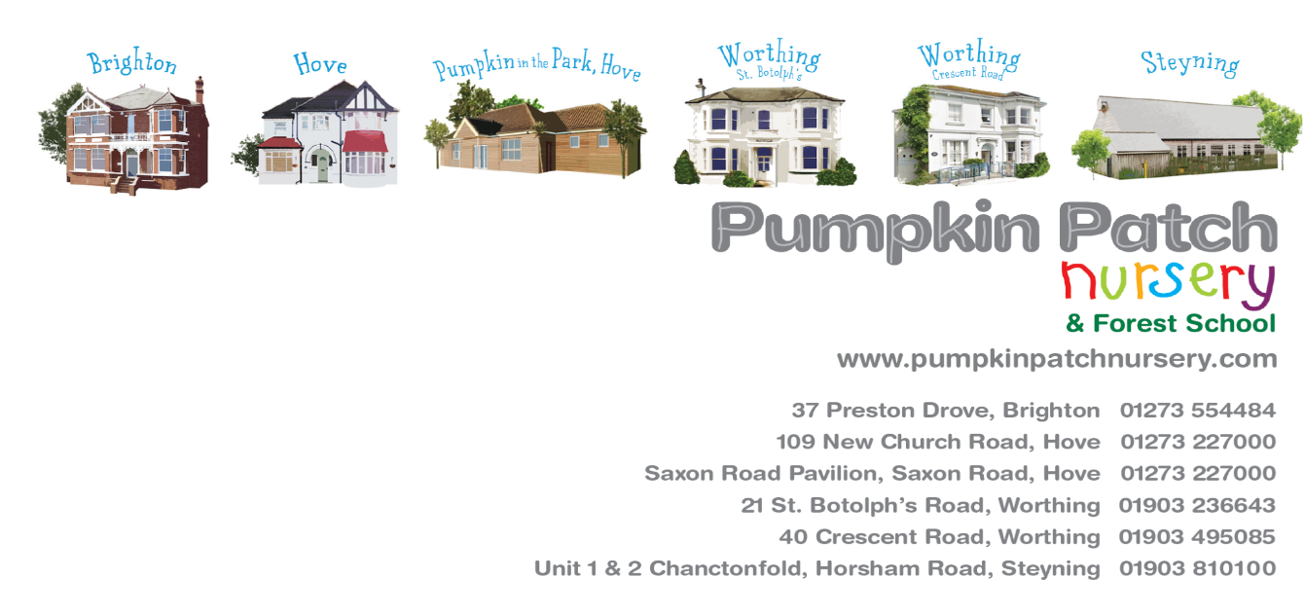

JOB Application Form

Date of application:
Position applied for:
Start date/hours of availability:
Where did you hear about this vacancy?

PERSONAL DETAILS

Surname:
First name:
Middle name/s:
Previous name/s:
National insurance number:

Email address:

Home number:

Mobile number:

Current home address:

Can we send work-related emails to your personal email address? | YES / NO

EDUCATION AND TRAINING
Please give details of ALL academic and vocational qualifications and training. Please include secondary, further, and higher education and continue on a separate sheet if necessary. You will be required to bring the relevant original certificates to interview.

Qualification gained / pending: | Grade / level: | Establishment school / college / university: | Date achieved: | Awarding body:
EMPLOYMENT HISTORY

Please give details of ALL previous employment. Please include paid and unpaid employment, work experience, placements, and voluntary work. Your start and end date much match up with the rest of your employment. Please indicate reasons for any gaps in employment over a 1-month period and continue on a separate sheet if necessary. If any information is missing or incomplete, you will be asked to complete the form again until the information is clear.

Employer / Company name: | Job title: | Main tasks and responsibilities: | Reason for leaving: | Start and end date of employment (month/year):
PERSONAL STATEMENT

Please tell us why you would be the ideal candidate for this role and what you could bring to the setting. Please include any personal attributes, qualities, and skills. Your personal statement may contribute to our overall decision.

REFERENCES
Please complete the referee details fully. One referee must be your most recent employer and preferably your most recent childcare employer before that. For students, one referee should be from your college. References will not be accepted from relatives or people you know as friends. References are usually taken up before interview. Please indicate if this is acceptable. Job offers are subject to satisfactory pre-employment checks including references.

 | REFEREE DETAILS 1 | REFEREE DETAILS 2
Full name:
Job Title:
Company:
Address:

Postcode:
Email Address:
Telephone Number:
Relationship to self:
Are you happy for us to request this reference immediately: | YES / NO | YES / NO
I understand that in line with safer recruitment, references must be scrutinised and questioned where necessary, therefore by signing this application form, I give consent to the relevant person to request further information should a reference not meet our standards, is incomplete, vague, or misleading. I also understand I should present any information that may impact my offer of employment directly to the relevant person at Pumpkin Patch Nursery.

DECLARATIONS

The information you provide will be handled and processed in accordance with the Data Protection Act 1998. It may be used by the employer for business purposes including the prevention and detection of fraud as well as for HR purposes and administration. If you are appointed, this information will form part of your personnel record and will be treated as confidential and will not be disclosed to any unauthorised person.
The position for which you are applying involves contact with children and is exempt from the Rehabilitation of Offenders Act 1974 and all subsequent amendments (England and Wales). For this position you are not entitled to withhold information about police cautions and convictions that have been made against you. Including any that would otherwise be considered ‘spent’ under the Act.

Appointment to this post is subject to a DBS (disclosure and barring services) and satisfactory pre-employment checks at a satisfactory level.
PLEASE CIRCLE THE APPROPRIATE ANSWER.
Have you ever received a caution, including conditional cautions, been convicted by a court of any offence, been reprimanded, or given a final warning? | YES / NO
Have you ever been dismissed, investigated into, or had any disciplinary action taken against you in the workplace? | YES / NO
Have you ever lived or worked outside of the UK? | YES / NO
Do you have evidence that you can live and work in the UK? | YES / NO

I declare that all information given as part of my application is true and I understand that any false, inaccurate, or incomplete information on my application form may result in dismissal, disciplinary action and may invalidate any contract of employment with Pumpkin Patch Nursery.

Date:

Signature:

